System Overview
Architecture Diagram
Our project's architecture is designed to be modular while remaining as simple as possible as seen in the diagram showing the structure and the interconnection between modules. Each module serves a specific purpose as outline in the Introduction section above. In addition to the basic four modules that were required from the project handout. We made an addition module called the FileParser to take the responsibility for reading in the commands from the text files.
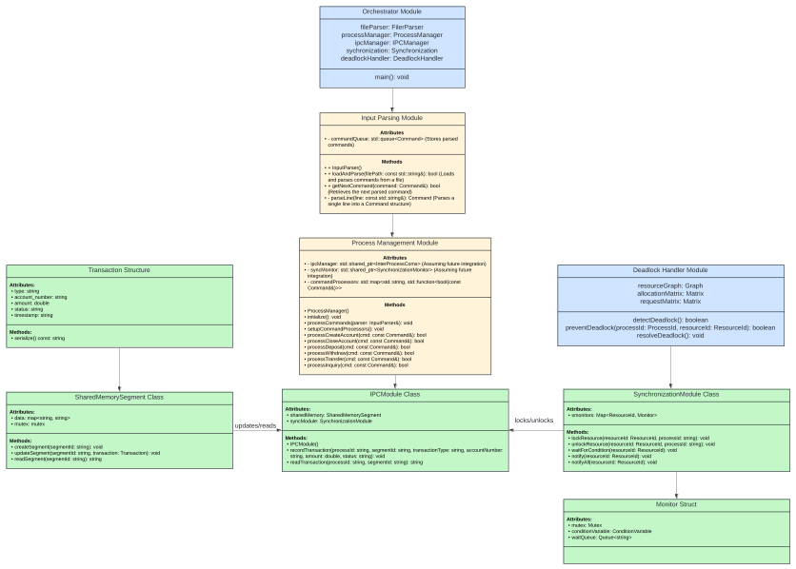
Component Description
- Driver: Serves as the central coordinating entity within the system. It integrates the File Parser and the Process Manager to start the progra.
- FileParser: Responsible for reading and processing input files, converting raw data into structured commands for further processing.
- ProcessManager: Manages the lifecycle of processes, including creation, execution, and termination.

- Input Parsing Module: Extracts and interprets user commands from input files, queuing them up for action by the system.
- commandQueue: Stores parsed commands, acting as an intermediary between raw input and actionable instructions.
- Process Management Module: Orchestrate processes, facilitating the execution of user commands through a set of defined operations related to banking transactions.
- ipcManager, syncMonitor: These attributes (presumably objects or pointers to synchronization and IPC tools) provide the necessary mechanisms for process synchronization and communication.
- command/Processors: Maps or associates transaction commands with their respective processors or handlers.
- Inter-process Communication Module: Facilitates the exchange of messages and shared data between processes to maintain consistency and coherency across the system's distributed components.
- messageQueue: Buffers messages for delivery between processes, ensuring that communication is orderly and non-blocking.
- sharedMemory: A mapping that correlates unique identifiers to data, enabling processes to share and access common information spaces.
- Synchronization Module: Implements critical concurrency control mechanisms that regulate process interaction, ensuring the integrity and isolation of operations on shared resources.
- mutexes: Provides mutual exclusion capabilities, safeguarding critical sections of code against concurrent access.
- conditionVariables: Allows processes to wait for certain conditions before proceeding, crucial in preventing race conditions and ensuring orderly execution.
- monitorQueue: A queue structure that holds processes waiting for their turn to access shared resources, ensuring fair and orderly scheduling.
- Deadlock Handler Module: Employs algorithms and matrices to detect, prevent, and resolve deadlocks, essential in maintaining the operational fluidity of the system.
- resourceGraph, allocationMatrix, requestMatrix: Data structures that track resource allocation and requests, forming the backbone of deadlock detection and resolution algorithms.
Each module's design follows established principles to support cohesive operation within a concurrent and shared-memory environment. Together, they represent a well-orchestrated effort to simulate a file-based banking system that operates with high reliability and integrity in a multi-process context.

